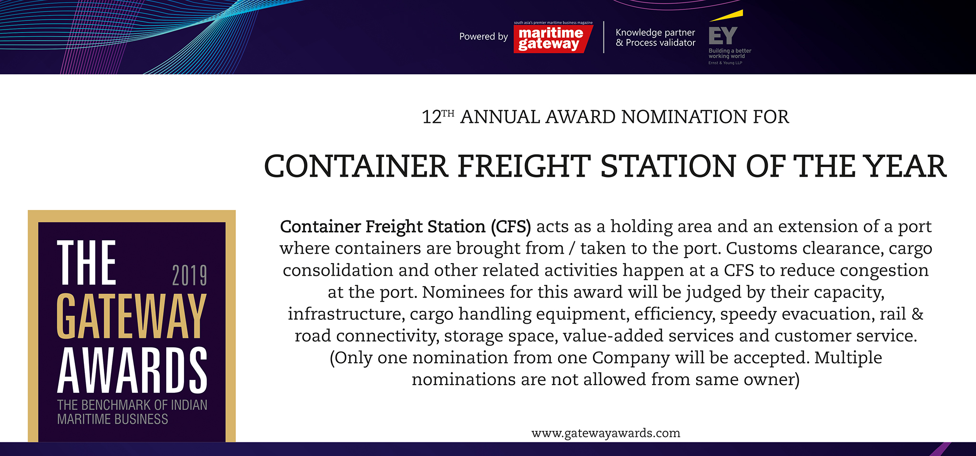

Please fill your responses and mail it to the address mentioned at the end of the Questionnaire

Note: All information and data should be provided for the FY 2018-19. In case, if you are unable to provide FY 2018-19 data, CY2018 information can be sent with a reason for not providing data for FY 2018-19.

Contact information:
Name of the Organization

Contact Person

Designation

Contact no.

Official Email ID

Address

Performance Indicators

Parameters | Units | Inputs
Throughput | TEUs
Growth rate (Y-o-Y, FY 2018-19over FY2017-18) | Percent

Efficiency Indicators

Parameters |  | Units | Inputs
Major export commodities |  | Names
Major import commodities |  | Names
Average Trailer Turnaround time (Gate Entry to Exit). |  | Hours
Total warehousing Space |  | Sq Meters
Cold Storage Space |  | Sq Meters
Total Ground Slots |  | Number
Average No. of containers  handled per day |  | Exports TEU
 |  | Imports TEU

Infrastructure Enhancements

Parameters | Inputs
Cargo handling equipment | Existing  equipment  (Number) | Rubber Tyred  Gantry Cranes | Reach  Stackers | Forklifts
 | New Additions in  FY 2018-19  /CY18 (Number) | Rubber Tyred  Gantry Cranes | Reach  Stackers | Forklifts

Innovations/ Investments/ Enhancements

Parameters | Type of inputs needed | Inputs
Innovations | • Qualitative, substantiated by quantitative facts  suggesting the milestones/improvements achieved  by the innovation  • Word limit ~ 200 words.
Technology  up-gradation | • Qualitative +quantitative inputs on up-gradation made and its impact (quantify the impact, if possible)  • Word limit ~ 200 words.
Investments made during the year | • Amount of investment in INR crore  • Qualitative inputs - need for investment, final outcome/  benefits), any other relevant aspect.  • Word limit ~ 200 words.

Please use below contact for sending filled-in form and also for any queries.

Rakesh Oruganti | Cell: +91 99483 34568;E mail ID: rakesh.oruganti@gatewaymedia.in

